**SENIOR HIGH SCHOOL DEPARTMENT**



**Badron, Ahmad G.**

**Grade 11 – STEM 2**

**Second Semester, SY 2020 - 2021**



**What is a portfolio?**

A portfolio is a showcase of all students’ work, it is a collection of work that students keep, reflect on and share with their parents. There will be four (4) areas that are evident.

1) Learner Profile

Reflect on student’s experiences in an online class and how these demonstrate MELCs.

2) Academic Progress

Reflect on student’s work and development or progress in his/her different subjects.

3) Reflection On Learning (ROL)

Reflection on student’s skills and the acquisition of MELCs.

4) Inquiry

Demonstrate the inquiry cycle across the curriculum (Inquiry, Action, and Reflection).

**Why do students keep a portfolio?**

The portfolio will help you in four ways:

1. You can reflect on your learning throughout the semester

2. You can organize the evidence of your work in a variety of areas.

3. You can share your accomplishments with your family and others.

4. You will use this as a final Performance Task in all your subjects every end of semester.

**What type of work does a student put in the portfolio?**

You include written works, performance tasks, essays, artworks, researches, certificates you earn from participating webinars or activities. If the work/project is too large to fit in your Portfolio, a photo may be attached to a paper that describes the work/project. Be sure the date is on all your work and don’t forget to complete the Assessment to Learning reflection for every work.

**Who will grade the portfolio?**

The student will self-assess the portfolio by using the student checklist at the end of every semester. The teacher will also evaluate it as a requirement for completing the semester.

**Organization of the Portfolio**

***Table of Contents***

1. Cover Page

2. IPSA Vision and Mission Statement.

3. Personal Page

4. Written works with ROL/Learning experiences in every subject.

7. Performance Tasks with ROL/Learning experiences in every subjects.

8. Other works (e.g. essays, art works, researches) with ROL/Learning experiences in every subjects.

9. End of Semester Reflection



**IPSA VISION and MISSION STATEMENTS**

**VISION STATEMENT**

International Philippine School in Al Khobar (IPSA) is a leading Filipino community school: pro-God, dynamic and

responsive to the needs of the learners

and the community.

**MISSION STATEMENT**

International Philippine School in Al Khobar (IPSA)

is committed to providing value-focused,

research-based, service-driven and

innovative education.

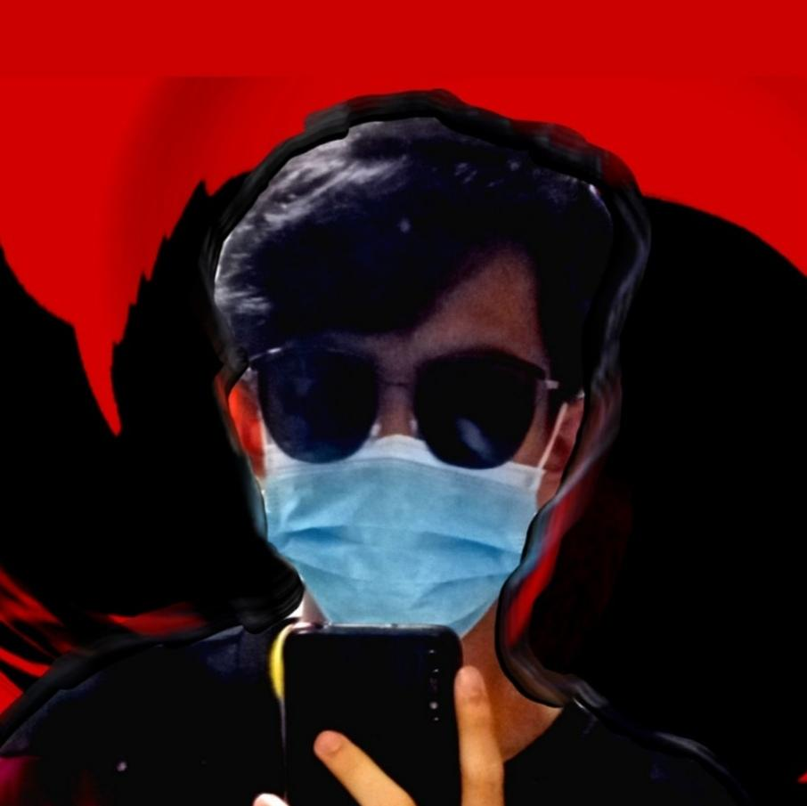

Personal Page

I am Ahmad Badron, and I may or may not consider myself an ambivert. And by that, I mean that I get very noisy with people I’ve known for long enough, and very silent around people I may know, but not too close to. I am a 5’7” (or 169 cm), 16 year old Filipino guy, born on a Tuesday, June 29, 2004 in Dammam Maternity Hospital, KSA. When I’ve got nothing to do, like nothing at all, I think about anything I can think of, and I brainstorm on it and come up with thoughts about the topic. So now you know about what goes in my head, when stationary. I’d say I am emotionally stable as a person. But kind of not too. I tend to overthink things, especially my friendships and relationships with people, which is a bad thing to do.

Currently, I am reading War and Peace, by Leo Tolstoy, and I’m not sure if I’m ever gonna finish it. First of all because it has 2000+ pages, and second that matters is that I’m not a reader of a person. So I’m not sure how this read is gonna go. I have played Lawn Tennis ever since I was young enough to be able to carry a racket in both my hands. And I still play it to this day. I like a lot of challenges, and thinking, so I try programming challenges that help me make algorithms that are actually useful in the long run. Mention the fact I also program. So far, the languages I have learned and have been able to program on are C++, Python, Javascript, and Java. HTML and CSS aren’t programming languages, mind you.

**Reading & Writing**

**Written Works**

**3rd Quarter**

1. Written Work 1

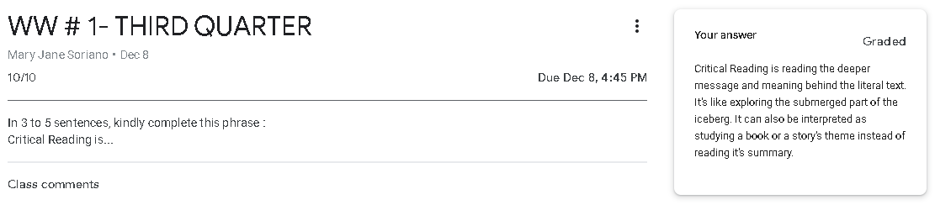

1. Written Work 2

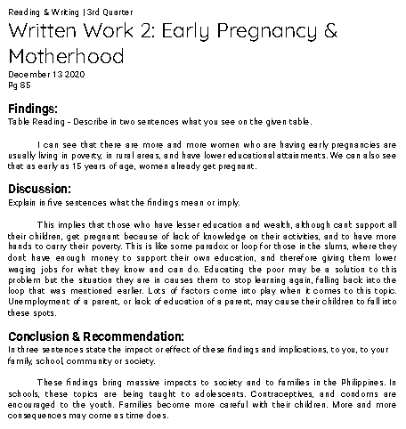

1. Written Work 3 (Group): Circle Chat

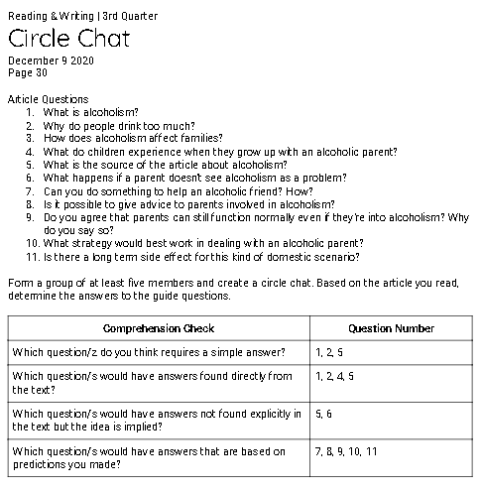

1. Written Work 4 (Group): Unified or Not?

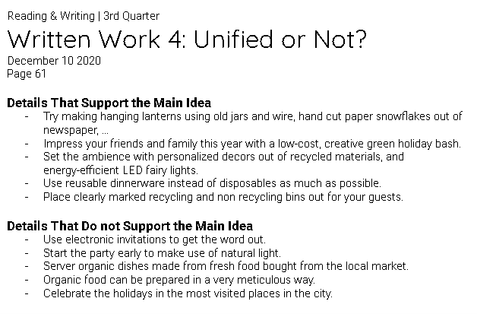

1. Written Work 5 (Group): Odd One Out!
2. Written Work 6 (Group): Revision through Cohesion

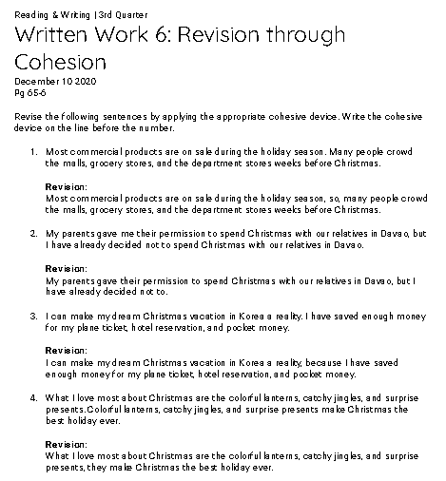

**REFLECTION ON LEARNING**

|  |
| --- |
| What are the Written Works?  **3rd Quarter**   1. Written Work 1 - **10/10** 2. Written Work 2 - **10/10** 3. Written Work 3: Circle Chat - **10/10** 4. Written Work 4: Unified or Not? - **10/10** 5. Written Work 5: Odd One Out! - **10/10** 6. Written Work 6: Revision through Cohesion - **12/12** |
| Explain what exactly you were required to do in these written works?  **3rd Quarter**   1. We were asked to continue this phrase: “Critical Reading is … ” in a short answer. 2. We looked at a table of data about early pregnancy and motherhood, and we were asked to reflect and give our findings based on the data. We wrote our output in paragraph form. 3. We listed down different types of questions based on the article we just read and the questions that came along with it. We did this activity with a group. 4. We picked out the sentences that didn’t support the main topic, and those that support the main topic. 5. We underlined the sentences that were out of order or sequence to evaluate the paragraph’s coherence. We did this activity with a partner. 6. We revised sentences that didn’t feel right with cohesive devices, and we did it as a group. |
| What information was the most interesting/surprising to you?  **3rd Quarter**   1. I was amused by the concept of critical reading, because I was aware of it but I wasn’t aware about it being a concept. 2. I was surprised to see that my expectations for the results weren’t what they turned out to be. I expected that the reckless teenagers would be more prone to early pregnancy, but it turned out that the 20-year-olds were more prone to pregnancy than the younger ages. 3. Questions can be put into different classifications, and with that, you have an idea on how to efficiently answer the questions. 4. Reading a paragraph without unity feels weird. The bits of the paragraph that don’t really point to the main idea distract the reader and causes them to lose grip of the main idea. 5. My reaction to this was pretty much the same with the last activity, but this time, we get the satisfaction of revising the wronged paragraph using cohesive devices. 6. Sentences can be easily fixed with just simple words such as “because”, and you can make the sentence be read smoothly without any doubt in it. |
| Which of the written works you did well? Why?  **3rd Quarter**  I’d say I have done well in much of the tasks given to us, despite missing the first day of classes. Because I participated, took my time, and kept up with the activities as much as possible. |
| In what written work do you need to improve? How?  **3rd Quarter**  I want to work on my motivation to read long passages. I have very bad attentiveness and I get hooked by my environment quickly. I need to work on focusing in class and focusing on what I’m doing. |

**Performance Tasks**

**3rd Quarter**

1. Mini Performance Task 1: Revising through Cohesion
2. Mini Performance Task 2

**REFLECTION ON LEARNING**

|  |
| --- |
| What are the Performance Tasks??  **3rd Quarter**   1. Mini Performance Task 1: Revising through Cohesion - **15/15** 2. Mini Performance Task 2: Comparing & Contrasting -**15/15** |
| Explain what exactly you were required to do in this Performance Task?  **3rd Quarter**   1. We were told to revise a paragraph using cohesive devices. 2. We were asked to compare and contrast two subjects in an essay form. |
| How may the skills that you have developed in this Performance Task be of help to you in your future career?  **3rd Quarter**   1. Cohesive devices are very useful when revising sentences and making the ideas flow smoothly as the reader reads it. 2. Having different ways to compare two topics is very handy, especially having two ways expressing your thoughts. |
| Which of the Performance Tasks you did well? Why?  **3rd Quarter**  I’d rather lean towards doing well in the first mini peta. Because I clearly understood the topic well among the others. I also did well in mini peta 2, because I had a good understanding of the activity and the topic. |
| In what Performance Task do you need to improve? How?  **3rd Quarter**  I’d gladly say I did well with most of the activities, it’s just that I feel like I was a bit tight on time, so I need to be more punctual. |

**PE & Health**

**Written Works**

**3rd Quarter**

1. Written Work 1

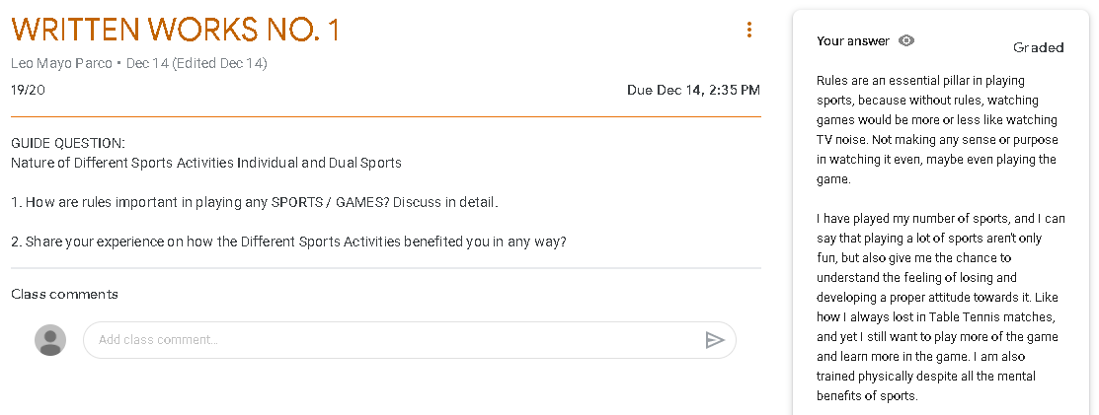

1. Written Work 2

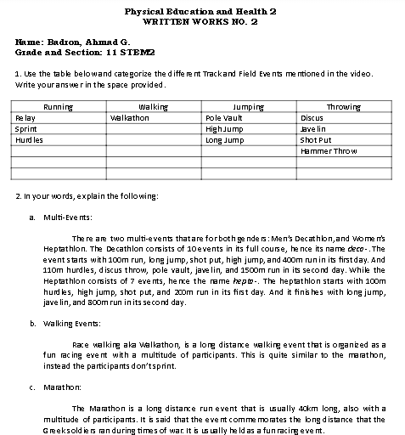

1. Written Work 3

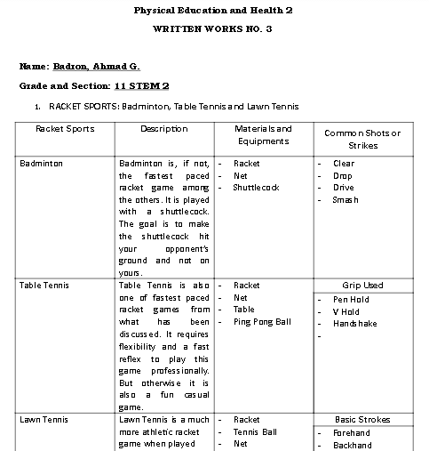

**REFLECTION ON LEARNING**

|  |
| --- |
| What are the Written Works?  **3rd Quarter**   1. Written Work 1 - **19/20** 2. Written Work 2 - **22/25** 3. Written Work 3 - **29/30** |
| Explain what exactly you were required to do in these written works?  **3rd Quarter**   1. We were asked two simple questions about sports, its rules, and how it benefited us in any way. 2. We filled in tables about athletic sports, a topic we recently just studied. We also assessed our knowledge of the said topic through defining and explaining three words related to the topic. 3. We filled in tables about the respective racket games we studied about. We were also asked to describe Pickleball and where it originated. |
| What information was the most interesting/surprising to you?  **3rd Quarter**   1. Sports as a topic itself got me hooked to it. I look forward to the lessons. 2. I was very interested in how the professional athletes who play the game have so much stamina, I wish I had a talent like theirs. 3. When it comes to my main sport, lawn tennis, I’m not that much of a geek. But this made me feel like one. I also always thought that table tennis was the fastest paced racket game out there, until I realized how badminton is professionally played. |
| Which of the written works you did well? Why?  **3rd Quarter**  I would come to an agreement with myself that I have done well in all of the written works, since most of the required tasks were just revolving around the same topic we just have discussed. |
| In what written work do you need to improve? How?  **3rd Quarter**  I do think that I don’t any much negative productivity this quarter, and I’m proud of that. I’m also proud to say I have to keep it up. |

**Performance Tasks**

**3rd Quarter**

1. Performance Task 1

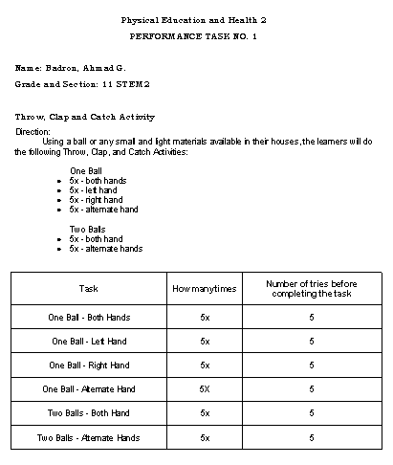

1. Performance Task 2

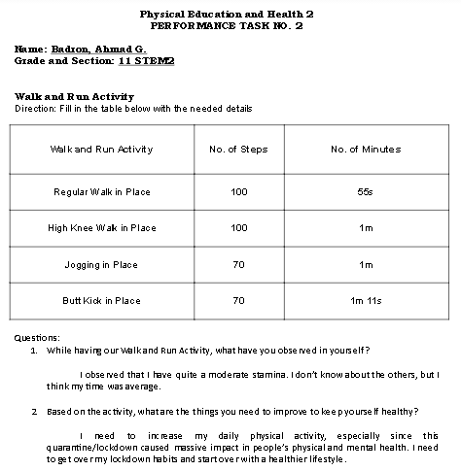

1. Performance Task 3

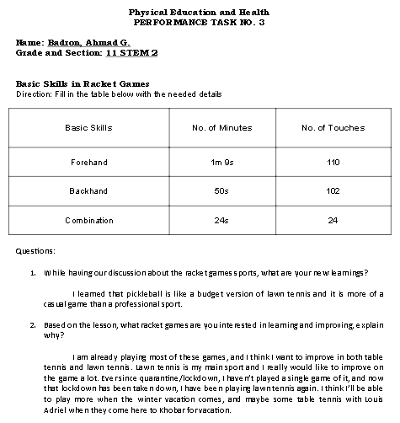

1. Performance Task 4

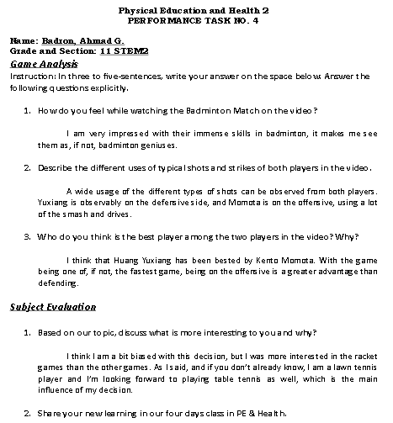

**REFLECTION ON LEARNING**

|  |
| --- |
| What are the Performance Tasks??  **3rd Quarter**   1. Performance Task 1 - **25/30** 2. Performance Task 2 - **29/30** 3. Performance Task 3 - **29/30** 4. Performance Task 4 - **30/30** |
| Explain what exactly you were required to do in this Performance Task?  **3rd Quarter**   1. In this performance task, we provided ourselves a small ball, or any material in its shape in the case there isn’t a ball. Then we threw the ball in the air, clapped our hands, and caught the ball again. We had to do this 5 times for certain circumstances. 2. In this performance task, we measured the time it took for us to walk, and jog in different paces and variations. 3. In this performance task, we provided ourselves a racket and a ball, makeshifts if not available. We measured how much we could do forehands, and backhands, and measured the time it took for us as well. 4. In our final performance task, we watched a video of two professional badminton players going at it with each other. We were asked to reflect and give our insights on the clip of the match. We also gave our opinion on the subject in its course of 4 days. |
| How may the skills that you have developed in this Performance Task be of help to you in your future career?  **3rd Quarter**   1. Hand-eye coordination is a serious thing in any field of competitive sports, and I think I just found a way to measure my hand-eye coordination with this activity. 2. Our legs are being used in our daily life indoor or outdoor, and since legs can be used in athletic professions, I think this can also be a measuring tool for when someone is planning on an athletic career. 3. As a lawn tennis player, I have been through this in my training stages, but I can still use this same technique for when I teach lawn tennis to younglings. 4. Game analysis are key factors when growing to be an iconic and strong athlete. Whether analyzing your games, or analyzing games of pros, it is always your advantage if you study where you went wrong, what you can do right, and etc. |
| Which of the Performance Tasks you did well? Why?  **3rd Quarter**  As with my response in the written works, I am proud to say I am content with my performance in all of the given tasks. |
| In what Performance Task do you need to improve? How?  **3rd Quarter**  And as I have previously mentioned, I am proud and satisfied with my products and in my opinion, there’s still room for improvement. |

**Disaster Readiness & Risk Reduction**

**Written Works**

**3rd Quarter**

1. Activity 1

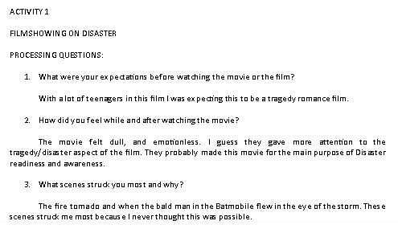

1. Activity 2

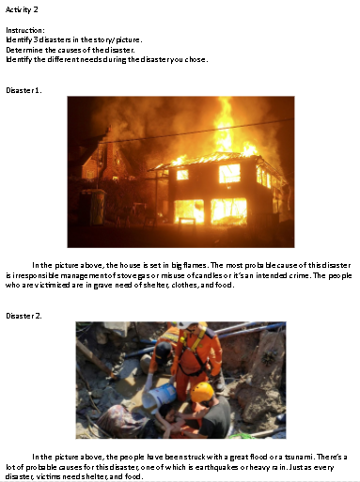

1. Activity 3

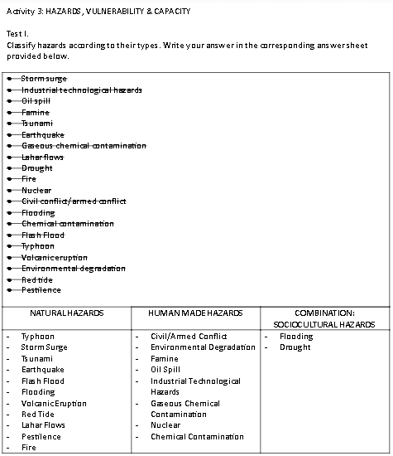

1. Written Work: Potential Earthquake Hazards

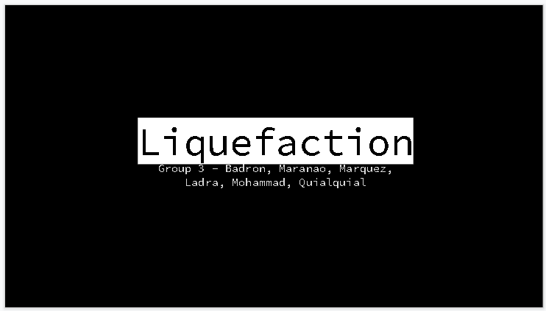

1. Written Work: Erupt-A-Word

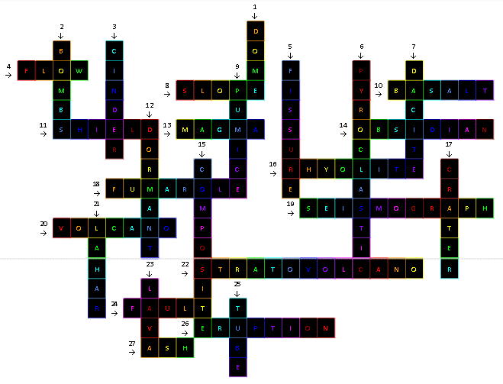

**REFLECTION ON LEARNING**

|  |
| --- |
| What are the Written Works?  **3rd Quarter**   1. Activity 1 - **30/30** 2. Activity 2 - **15/15** 3. Activity 3 - /30 4. Written Work: Potential Earthquake Hazards - **20/20** 5. Written Work: Erupt-A-Word - /27 |
| Explain what exactly you were required to do in these written works?  **3rd Quarter**   1. In this activity, we watched an hour-long tragedy movie concerning disaster readiness and awareness. Then we were asked to reflect on the events in the movie. 2. In this activity, we were split into breakout rooms. Then we picked out pictures that we could tell stories we could relate it to. Then in a Google Docs file, we picked out 3 images to explain the situation/disaster that occured to them. 3. In this activity, we sorted different kinds of hazards into 3 categories. Then we identified different words related to disaster readiness, hazards, and etc. 4. In this written work, we were grouped into breakout rooms. Each group was assigned a potential earthquake hazard. My group was assigned to Liquefaction or Soil Liquefaction. Later, our group’s assigned reporter explained and discussed our accumulated information to the class. 5. In this written work, we were given two hyperlinks to pages that contained information for a crossword we had to fill in. |
| What information was the most interesting/surprising to you?  **3rd Quarter**   1. I’m quite surprised that although people have been taught disaster drills, especially students, almost all their lives, they still gave a number of casualties to the tornadoes. 2. I’ve come to realize that no matter what we do, disasters will always bring casualties to the table, and there’s no way around it. But what we do know is that we can prevent a larger and greater number of casualties and unfortunes. 3. Being able to classify different hazards is one step towards preventing/preparing for it. Learning about them thoroughly is an even larger one. 4. Now is the only time I learned about Soil Liquefaction, I never knew that the solid ground that I know can be as unstable as liquid water. 5. I was so interested in the different types of lava. I never learned about it until now. |
| Which of the written works you did well? Why?  **3rd Quarter**  I’d like to point out that I appreciated the second activity a lot. Sharing stories and experiences with people help share the lessons we might have pulled out from it. And me having experienced some tragedies for myself, it’s nice to open it up to people. |
| In what written work do you need to improve? How?  **3rd Quarter**  I feel like I should’ve paid more attention to the movie we watched. That’s just the only doubt I have for myself this quarter. |

**Performance Tasks**

**3rd Quarter**

1. Mini Performance Task: Hunt for Hazards

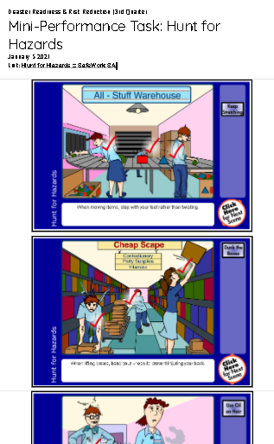

1. Mini Performance Task 2: Tsunami

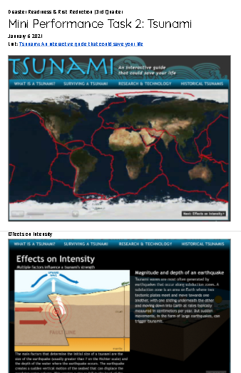

**REFLECTION ON LEARNING**

|  |
| --- |
| What are the Performance Tasks??  **3rd Quarter**   1. Mini Performance Task: Hunt for Hazards - **50/50** 2. Mini Performance Task 2: Tsunami - /50 |
| Explain what exactly you were required to do in this Performance Task?  **3rd Quarter**   1. In this performance task, we hopped on a flash animation. In the flash animation, we determined the most probable hazards in workspaces and everyday life as well, and dragged to it some possible solutions to them. 2. In this performance task, We hopped on another flash animation where tsunamis were elaborately explained. A couple or more video footage of tsunamis were included in the flash animation as well. Then we had to screenshot every page of the flash animation and put it in a Docs file. |
| How may the skills that you have developed in this Performance Task be of help to you in your future career?  **3rd Quarter**   1. One way or another, everyone is still going to be having a job. And when working, hazards will always be present, since we’re not in a perfect ideal world. Learning about these hazards and studying how we can avoid them as much as possible beforehand will be a great advantage for when we set foot into the world of labor. 2. I think being prepared for a tsunami beforehand is very helpful for when the real thing comes. Especially since the Philippines is part of the Pacific Ring of Fire where most seismic activities happen in the world. |
| Which of the Performance Tasks you did well? Why?  **3rd Quarter**  I did well in all the performance tasks. They were all understandable and with the right motivation despite having the same class for a week straight. |
| In what Performance Task do you need to improve? How?  **3rd Quarter**  So far, good progress, keep it up for next quarter. |

**Komunikasyon at Pananaliksik**

**Written Works**

**3rd Quarter**

1. Gawain 1
2. Gawain 2
3. Gawain 3
4. Gawain 4

**REFLECTION ON LEARNING**

|  |
| --- |
| What are the Written Works?  **3rd Quarter**   1. Gawain 1 - **20/20** 2. Gawain 2 - **20/20** 3. Gawain 3 - **13/16** 4. Gawain 4 - **10/10** |
| Explain what exactly you were required to do in these written works?  **3rd Quarter**   1. Sa gawaing ito, sinagutan namin ang pahina 146 B at ang pahina 151 Salok-Dunong. 2. Sa gawaing ito, sinagutan namin ang pahina 158 A at ang pahina 163 Salok-Dunong. 3. Sa gawaing ito, sinagutan namin ang pahina 172 B at ang pahina 177 Salok-Dunong. 4. Sa gawaing ito, sinagutan namin ang pahina 191 Salok-Dunong. |
| What information was the most interesting/surprising to you?  **3rd Quarter**   1. Natutunan kong marami pala tayong mga salitang ginagamit na hindi naman salita sa wika. 2. Natutunan kong mas komplikado ang pakikipag-komunikasyon sa tao mula sa ating alam. 3. Natutunan kong kasama rin ang mga di-berbal na kilos sa pakikipag-komunikasyon. 4. Natuklasan kong pwede ko palang pahabain ang aking mga sanaysay gamit ng kakayahang diskorsal. |
| Which of the written works you did well? Why?  **3rd Quarter**  Nagawa ko lahat ng maigi dahil nasundan ko yung klase. |
| In what written work do you need to improve? How?  **3rd Quarter**  Siguro yung Gawain 3. Pero normal naman po magkamali, ‘di ko lang po ata napag-isipan ng maayos. |

**Performance Tasks**

**3rd Quarter**

1. Mini Performance Task: Pagsusuri ng Speech Act

**REFLECTION ON LEARNING**

|  |
| --- |
| What are the Performance Tasks??  **3rd Quarter**   1. Mini Performance Task: Pagsusuri ng Speech Act - |
| Explain what exactly you were required to do in this Performance Task?  **3rd Quarter**   1. Sa mini peta na ito, pinanood namin ang pelikula na “Guerrero” at kumuha ng mga linya mula sa pelikula. Sinuri din namin kung anong klaseng Speech Act ito. |
| How may the skills that you have developed in this Performance Task be of help to you in your future career?  **3rd Quarter**   1. Makakatulong ito dahil ang araw-araw buhay sa mga susunod na taon ay magiging puno ng komunikasyon ng iba't ibang uri, kaya ito importante. |
| Which of the Performance Tasks you did well? Why?  **3rd Quarter**  Sa palagay ko, nagawa ko itong performance task nang maigi, dahil nakasabay nga ako sa *discussion* ng klase at naintindihan ko ang aralin. |
| In what Performance Task do you need to improve? How?  **3rd Quarter**  Tulad ng aking palagay kanina, nagawa ko nang maigi ang performance task na ito. |

**Understanding Culture, Society, and Politics**

**Written Works**

**3rd Quarter**

**REFLECTION ON LEARNING**

|  |
| --- |
| What are the Written Works?  **3rd Quarter** |
| Explain what exactly you were required to do in these written works?  **3rd Quarter** |
| What information was the most interesting/surprising to you?  **3rd Quarter** |
| Which of the written works you did well? Why?  **3rd Quarter** |
| In what written work do you need to improve? How?  **3rd Quarter** |

**Performance Tasks**

**3rd Quarter**

**REFLECTION ON LEARNING**

|  |
| --- |
| What are the Performance Tasks??  **3rd Quarter** |
| Explain what exactly you were required to do in this Performance Task?  **3rd Quarter** |
| How may the skills that you have developed in this Performance Task be of help to you in your future career?  **3rd Quarter** |
| Which of the Performance Tasks you did well? Why?  **3rd Quarter** |
| In what Performance Task do you need to improve? How?  **3rd Quarter** |

**OTHER WORKS**

**WORK #1**: (put the name of work here)

**REFLECTION ON LEARNING**

|  |
| --- |
| Explain what exactly you were required to do in this work? |
| How may the skills that you have developed in this work be of help to you in your future career? |

**WORK #2**: (put the name of work here)

**REFLECTION ON LEARNING**

|  |
| --- |
| Explain what exactly you were required to do in this work? |
| How may the skills that you have developed in this work be of help to you in your future career? |

**WORK #3**: (put the name of work here)

**REFLECTION ON LEARNING**

|  |
| --- |
| Explain what exactly you were required to do in this work? |
| How may the skills that you have developed in this work be of help to you in your future career? |

**WORK #4**: (put the name of work here)

**REFLECTION ON LEARNING**

|  |
| --- |
| Explain what exactly you were required to do in this work? |
| How may the skills that you have developed in this work be of help to you in your future career? |

**CERTIFICATES**

(put scanned copy or picture of your certificates here)

**End of Semester Reflection**

**1. What helped you achieve or pass your subjects this semester? What prevented you from giving your best?**

Answer:

**2. What is something you did really well or tried your best at during this semester?**

Answer:

**3. What is something that you didn’t do as well as you could have or something that you would like to improve?**

Answer: